2007 New Year’s Message

GRATITUDE

A New York paper devoted many pages over several weeks printing letters of children to Santa Claus. Several weeks after Christmas, an editorial was printed stating that of the thousands of letters, only one writer followed up with a letter of thanks to Santa Claus after Christmas.

Someone has said, “These days if you want to find gratitude, look for it in the dictionary.”

**in•grate** *noun*[Latin *ingratus* ungrateful, from *in- + gratus* grateful (1622)**:** an ungrateful person

It should be pointed out that **thinking precedes giving**. When we are presented with a gift, it means that someone has been thinking about us. **Thinking should also precede thanking**. It is not the gift itself that should occupy our thoughts but the thoughtfulness of the giver. This stops the practice of “looking a gift horse in the mouth”.

True appreciation is expressed on the basis of the giver, not the gift.

Many people have no idea how much thought, time, effort, and money went into things that were done for them. Example: taking time to invite them over, cleaning the house, putting away all the clutter, mowing the yard, shopping for food that they would like, cooking dinner, baking pies, cakes, and cookies, buying gifts, writing notes, sending cards, decorating for the holidays, serving them, washing all the dishes and tablecloths, and putting everything away again.

To produce DVDs for Country Bible Church involved a lot of thought, time, effort, and money. 1st, the idea and getting technical advice, choosing a camera, locating and buying the camera, buying a special battery for the camera, buying the right computer, getting the right cables (not firewire), buying video adapter apparatus,getting right software, mounting device for camera, installing cables in tight areas, in mud, dirt, and cobwebs under the church, buying DVDs, Recording / / Editing / Saving videos, finding and then buying DVD printer, making copies of DVDs, putting labels and names on the copies, placing them in the rear of the church, and sending them out through the mail.

# A Thankful Pastor

Dr. Alexander Whyte of Edinburgh was famous for his pulpit prayers. He always found something to thank God for, even in bad times. One stormy morning, a member of his congregation thought to himself, “The preacher will have nothing to thank God for on a wretched morning like this.” But Whyte began his prayer, “We thank Thee, O God, that it is not always like this.”

# Pastor’s Conclusion

A clergyman included in his annual parochial report the item “Nine Persons Lost At Sea.” When the congregation expressed shock and amazement, he said, “Well, eleven persons requested prayers for those going to sea, and only two asked me to give thanks for a safe return, so I assume that the other nine were lost at sea.”

Dr. David Soper, in *God Is Inescapable*, suggests that the basic difference between a prison and a monastery is jthe difference between griping and gratitude. Undoubtedly this is true. Imprisoned criminals spend every waking moment griping; self-imprisoned saints spend every waking moment offering thanks. Dr. Soper says that when a criminal becomes a saint, a prison may become a monastery, and when a saint gives up gratitude, a monastery may become a prison.

**When you drink from the stream, remember the spring.** — Chinese Proverb

“The man who has forgotten to be thankful has fallen asleep in life.” --- Robert Lewis Stevenson

*Manners are a behavior learned by enforced humility or example set by parents. Good manners express thoughtfulness and gratitude toward others. However, there is **a superior thoughtfulness and gratitude** acquired when capacity is developed from spiritual growth that comes through consistent intake of Bible doctrine. First, we learn to appreciate the Lord through His Word, and then we are able to appreciate others.

***\*Col 2:7 - having been firmly rooted and now being built up in Him and established in your faith, just as you were instructed, and overflowing with gratitude.***

*We express our gratitude to God in song and prayer which are forms of worship, ***Heb. 13:15 – sacrifice of praise and thankfulness*.** We express our gratitude to others by saying “Thank you”.

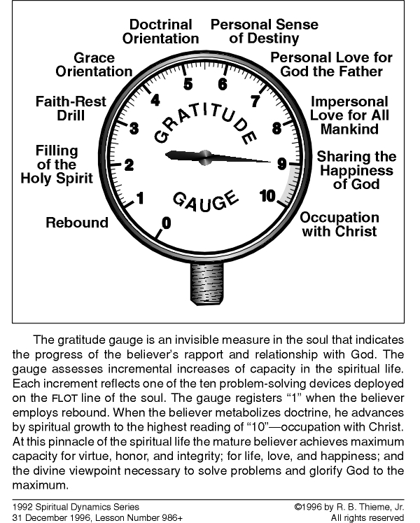

ADOLESCENT

B.D.

B.D.

B.D.

B.D.

B.D.

B.D.

**Where did you measure in 2006?**

BABY

**Self-absorbed**

**Thoughtless**

**Ungrateful**

ADULT

**God/Others**

**Thoughtful**

**Grateful**

F.H.S. & B.D.

# POINTS

1. If you don’t have the capacity for thanksgiving, you don’t have the capacity to love anyone except yourself.

2. Arrogance is devoid of gratitude. No matter what you do for an arrogant believer, he will never appreciate it. Obviously then, the arrogant believer can’t appreciate what God has done and is doing for him. People who are ungrateful to God are also ungrateful to people.

3. How can a believer be thankful for what God has done if he doesn’t know what God did for him? How can he be grateful for the opportunity of receiving eternal decorations and rewards if he has no knowledge of such things?

4. An arrogant person has no gratitude in his soul. He is not a good lover, a good friend, or a good human being. He is the source of his own misery and often makes those around him miserable as well. He has nothing to give the Lord in worship.

5. There is no way that you can truly have gratitude in your soul unless you are learning doctrine, unless you are consistent in living and residing inside the Divine Domain in the filing of the Holy Spirit, and unless you have a genuine personal love for God.

6. True thanksgiving / appreciation is the beginning of capacity for life. When you are truly grateful for what has been done for you, you are developing capacity for life and happiness. This usually starts with appreciation for parents.

Eph. 5:20 - always giving thanks for all things in the name of our Lord Jesus Christ to God, even the Father;

***1 Thes 5:18 - In everything give thanks; for this is the will of God in Christ Jesus concerning you.***

***1 Corinthians 15:57 - but thanks be to God, who gives us the victory through our Lord Jesus Christ.***

***2 Tim 3:2-7* -** ***For persons*** [believers] ***will be lovers of self, lovers of money, boastful, arrogant, slanderers, disobedient to parents, ungrateful, wicked, without virtue-love, malicious gossips, without self-control, brutal, not lovers of God, treacherous, thoughtless, conceited, lovers of pleasure rather than lovers of God, having a form of godliness but having denied its power, in fact, avoid such persons as these.***